**Both solutions has sth to do with linked,eventhandler functions**

**Idea 1:** change fill or path value of state in geopath

// To do: to change the states class css attribute as a function, which takes eventhandler from treemap

// when us.objects.states match in the us match with the state number in treemap, that state shows a different fill

Us object structure

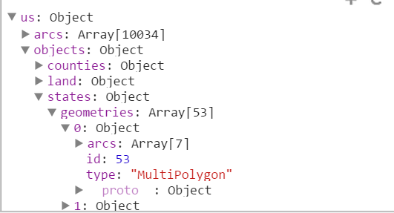

Something like this maybe in http://chimera.labs.oreilly.com/books/1230000000345/ch12.html#_choropleth the graph

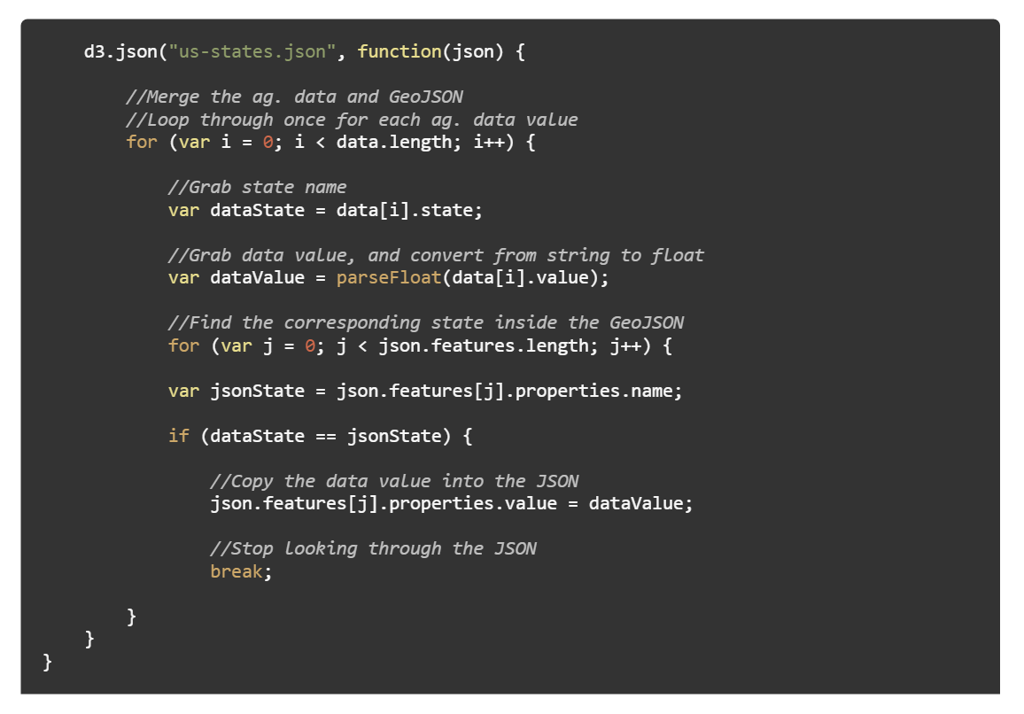

Idea 2, add a check mark or dot or sth over a coordinate point of the state when the treemap cooresponding state is hovered

Like in the visualization book, there is code and a tool to generate coordiante for cities

http://www.gpsvisualizer.com/geocoder/

